Murweh Shire Council
Application for Depasturing Stock 2022/2023
95-101 Alfred Street PO Box 63 Charleville Qld 4470
Telephone: 07 4656 8355
ABN: 98 117 909 303
Email: mail@murweh.qld.gov.au
Website: www.murweh.qld.gov.au

Applicant Details | Full name:
 | Residential address:
 | Postal address: |  | As above
 | Email:
 | Telephone:
Common/  Reserve | I hereby make application to Murweh Shire Council to depasture the following stock on:  Augathella Common Reserve  Charleville Common Reserve  Morven Common Reserve  Other Common Reserve (Please specify which reserve _________________________
Stock Details | Tag Number | Description of stock |  | Sex | Brand | Brands and Ear Marks/Tags
Declaration | I declare the information provided in this application is true and correct in every detail and that I have read the Council’s terms and conditions.  Applicant’s signature ………. Date / /

REGULATIONS FOR DEPASTURING STOCK - MURWEH SHIRE

- Council approval must be given prior to release of stock on all reserves.

- Applications to depasture stock must be made in writing to council.

- Descriptions of brands and earmarks are to be included in any new application, and any changes to these must be made in writing to council.

- Cattle are to be ear tagged with Council issued tags prior to release, any stock not ear tagged will be impounded. Tags will be numbered to maintain records.

- Written notice must be given to council to advise any change in numbers.

- Cattle yards, and traps will be locked, keys held by council.

- Any individual muster will only be allowed on the last weekend of every second month beginning January each year and all other agistees must be notified. Mustering outside these times will only be allowed at council discretion.

- Ear tags are to be returned to the Town Ranger when cattle are removed.

- Stock deemed to have lost an ear tag can be re-tagged at the discretion of the Town Ranger.

- Owners are to dehorn or tip all stock.

- In the event of trapping stock on the watering facility enclosures, unwanted cattle are to be released hourly.

- The use of motorbikes for mustering will be approved at the discretion of the Town Ranger.

- Weaners 6 months or older will be included in the agistees total allowed number, and therefore must be adjusted accordingly. Excess numbers will be impounded if not removed.

- Any owner reporting lost stock from his quota must wait a period of three (3) months before restocking.

- Council reserves the right to alter the number of stock on reserves, as it sees fit.

- Applications for depasturing stock will lapse within three (3) months from the date of approval, if not fulfilled.

- Council Local Laws are to be adhered to. These can be viewed on the Murweh Shire Council website or at the Council office.

- Any person found interfering with a Council muster will be prosecuted.

- Timber treatment/weed control will be as per relevant management plans.

- These conditions apply to all Murweh Shire Town commons and reserves.

- Any person not wishing to abide by these conditions will have their stock removed, and rendered unable to depasture stock on any Council Reserve.

- All agistment fees are to remain in one month in advance, paid on the first Tuesday of every month between the hours of 8.00am and 12 noon, at the Augathella Library, Morven Depot, Murweh Shire Council office Charleville.

- Stock Routes Supervisor to be in attendance at all musters.

Bred By: _________________________________

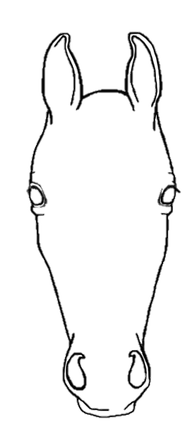
Name: __________________________________

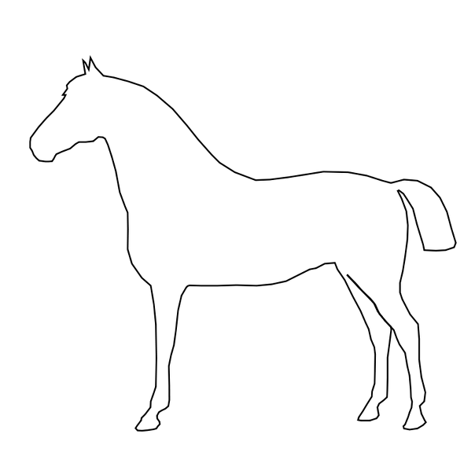
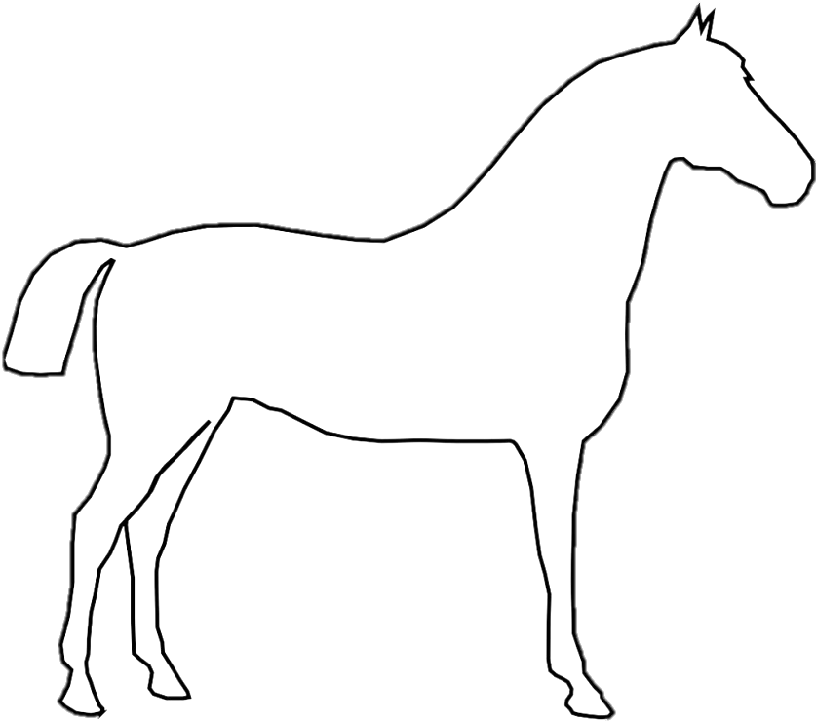

Bred By: _________________________________

Name: __________________________________

